Rural Innovation Fund
2022 - 2025

Rural Innovation Fund Application Form

An application form may be submitted in Welsh and any application submitted in Welsh shall not treated less favourably than a request submitted in English

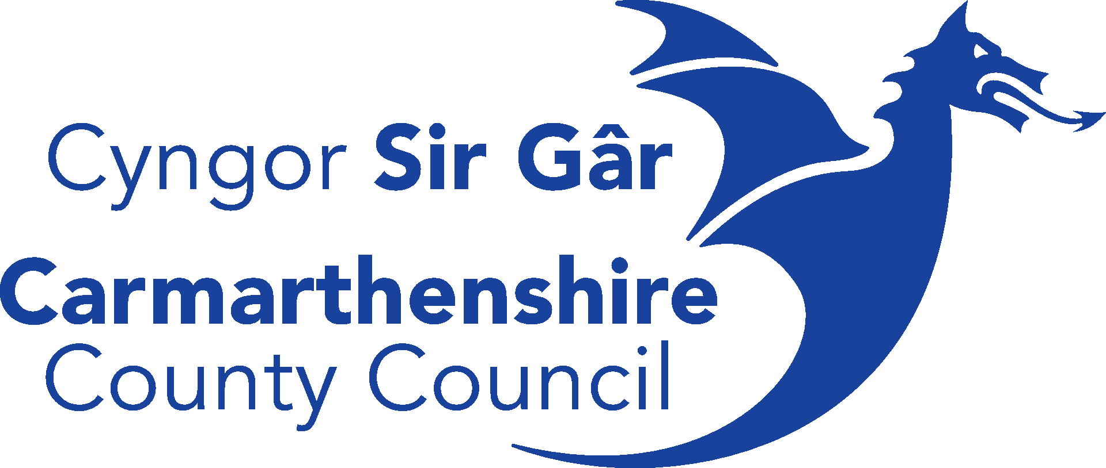

Please answer all questions and tick appropriate boxes where necessary.
Incomplete forms cannot be accepted and will be returned to the applicant.
This application is to be completed in conjunction with the Rural Innovation Fund Guidance Notes.

SECTION 1 – APPLICANT’S DETAILS
Name of Organisation:
Main Contact Name:

Position held in Organisation:

Organisation’s address:

Postcode:

Telephone No:

E-mail:
Project geographical area:
SECTION 2 - TYPE OF GROUP / ORGANISATION
What is the status of your Organisation? (Including any registered numbers)
e.g., Charity, Community Council, Business, Social Enterprise, Other (please specify below)

Please indicate which of the identified key priorities your project will seek to address.
(Please refer to Rural Innovation Fund guidance)
Priority:

SECTION 3 - PROJECT DETAILS
Project Title:

Project Activities

Who will benefit from this project?

What challenges/need will this project address/tackle?

Please provide details of community engagement/consultation that you have undertaken to ensure that this project will be supported within your area.

SECTION 4 - CARMARTHENSHIRE’S LOCAL INVESTMENT PLAN
How does your project align to Carmarthenshire’s Local Investment Plan?

SECTION 5 - INNOVATION
How is this project innovative?
Please refer to at least one for the following within your answer: new processes, new services, new approaches, new products.

SECTION 6 – PROJECT OUTPUTS
Please estimate which of these programme outputs your project will contribute to. Please refer to Annex C in Programme Guidance Notes when completing this section.
Indicator | Amount | Rationale| evidenced by
Number of local events or activities supported
Number of volunteering opportunities supported
Number of people reached
Number of feasibility studies supported
Number of people attending training sessions
Number of jobs created (as a direct result of the project but cannot relate to project delivery staff employed)

SECTION 7 – SUSTAINABILITY AND RISK MITIGATION
Please identify any risks that may result in the project not being completed and how you propose to mitigate these risks.

How will the project be sustainable after the funding period? Or what is your exit strategy for this project?

SECTION 8 - PROJECT MANAGEMENT
Outline your organisations experience, capacity and ability to deliver this project to include details on how this project will be managed to ensure successful.

SECTION 9 – IMPACT ON THE WELSH LANGUAGE
The Welsh Language Standards Compliance Notice places a statutory requirement on the Council to ensure that the grants it awards have a positive effect on opportunities for persons to use Welsh, and on not treating Welsh less favourably than English.
Please refer to Annex D of the guidance notes when completing this section.
How are you going to ensure your proposed project will ensure that the Welsh language is treated as favourably as the English language in the planning and administration of the project?

How are you going to ensure your proposed project has a positive impact on opportunities to use Welsh?

How will you and any third party or partner promote your Welsh medium provision to the county's communities?

SECTION 10 – CROSS CUTTING THEMES
All projects are required to demonstrate how they will address the following cross cutting themes. Please refer to Annex E of the guidance notes when completing this section.
Sustainable and low carbon approaches to delivery
Digitally accessible services
Equality of Opportunity

SECTION 11 – PROJECT TIMESCALES
Please note all projects must be completed no later than October 2024 and delivery period cannot be more than 12 months

_______ Months

Proposed Start Date: Proposed End Date:

SECTION 12 – COSTS BREAKDOWN
Please complete the Project costs spreadsheet with further detail. Refer to Annex B for Procurement.
Amount (£)
Total project cost
Request for funding
Cannot exceed £45,0000

SECTION 13 – VAT
Is your Group / Organisation VAT Registered? YES/NO
Can the organisation reclaim VAT? YES/NO
VAT Registration No:

SECTION 14 – SUBSIDY CONTROL
Should your application be successful, would the direct award of UKSPF funds to you (as the applicant) considered to be a subsidy?
YES/NO
Please refer to Annex F in the Guidance to explain the rationale for your response.

If the award is considered a subsidy, applicants are required to provide details of any financial assistance received from public authorities within the last 3 years
Funder | Amount | Date funding received by applicant

SECTION 15 – CHECKLIST
Please ensure all the following documents and evidence are submitted with this completed, signed application form
Completed Application Form
Statutory Consents incl. Planning permission, building regulations (if applicable)
Proof of match funding from other funding sources (if applicable)
Conflict of interest acknowledgment
Constitution documents
Copy of latest available accounts
Completed budget spreadsheet
Bank statement
Welsh Language Policy
Equal Opportunities Policy

SECTION 16 – DECLARATION
I declare that the information given on this form is accurate and true.
 | Signatory 1 | Signatory 2
Print Name
Signature
Position
Date

Please return electronically to rdpsirgar@carmarthenshire.gov.uk

How we use your information

Carmarthenshire County Council collects personal data about you using this form so that we can process your application for funding. To find out more about how we use your information, please visit our website www.carmarthenshire.gov.wales to obtain our Privacy Notice.

‘Mae croeso i chi gysylltu gyda’r cyngor trwy gyfrwng y Gymraeg neu’r Saesneg.
You are welcome to contact the council through the medium of Welsh or English’.

